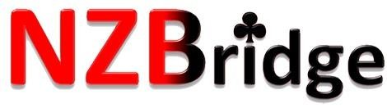
PLAY SESSION 7: STUDENT NOTES
Pre-emptive Openings

Pre-emptive Opening Bids
2-level openings (except 2♣) show 6-10 and a good 6-card suit 3-level openings show 6-10 and a good 7-card suit
4-level openings show 6-10 and a good 8-card suit
The pre-emptive opening is a destructive opening.
Once you open you will rarely bid again – it will be up to partner to choose the final contract

Opening 2♦ 2♥ 2♠
▪ 6-10
- 6-card suit (2+ honours)

Responses
Pass | 0-13 | any shape
3♦ 3♥ 3♠ | 14-15 | 2+ card support
Raise to Game | 16+ | 2+ card support or any HCP & 4+ support
New Suit | 17+ | Good 6-card suit – forcing (rarely used bid)

Opening 3♣ 3♦ 3♥ 3♠
▪ 6-10
- 7-card suit (2+ honours)

Responses
Pass | 0-13 | any shape
Raise to Game | 16+ | 1+ card support or any HCP & 3+ support
New suit at 3-level | 17+ | Good 6-card suit – (rarely used bid)

Opening 4♥ 4♠
▪ 6-10
- 8-card suit (2+ honours)

Responses
You have reached game - no need to bid on!

Examples:
♠ KJ107543 | ♠ 2 | ♠ J2 | ♠ AQJ87432 | ♠ 4
♥ AJ3 | ♥ AQ8762 | ♥ A73 | ♥ 43 | ♥ J62
- K8 | ♦ 962 | ♦ J98542 | ♦ 74 | ♦ 54
♣ 7 | ♣ K72 | ♣ KJ4 | ♣ 9 | ♣ KQJ8763
Open 1♠ | Open 2♥ | Pass (poor suit) | Open 4♠ | Open 3♣

